**MOHITE CONSULTANCY SERVICES**

C-18, Shivshakti Sangh, New Sambhaji Nagar, Near Karnatak School, Ghatla, Chembur (E), Mumbai - 400071.

**Mobile:** 9619156719 E-mail**:** tusharmohite0@gmail.com

To,

The office of the Service Tax Commissioner,

Divisional Group – III,

Service Tax Division –II,

Service Tax Commmissionerate - VII - Mumbai,

**Sub : Details of the main Bank Account**

Dear Sir,

With reference to the captioned subject, details of our main bank account are as follows:

Bank Name: Mumbai District Central Co-Op Bank Ltd.

Branch: Chembur, Mumbai.

IFSC Code: MDCB0680009.

MICR Code: 400068009.

Account No: 00091101000554.

Account Type: Current.

Scanned copy of the blank cheque for your reference:

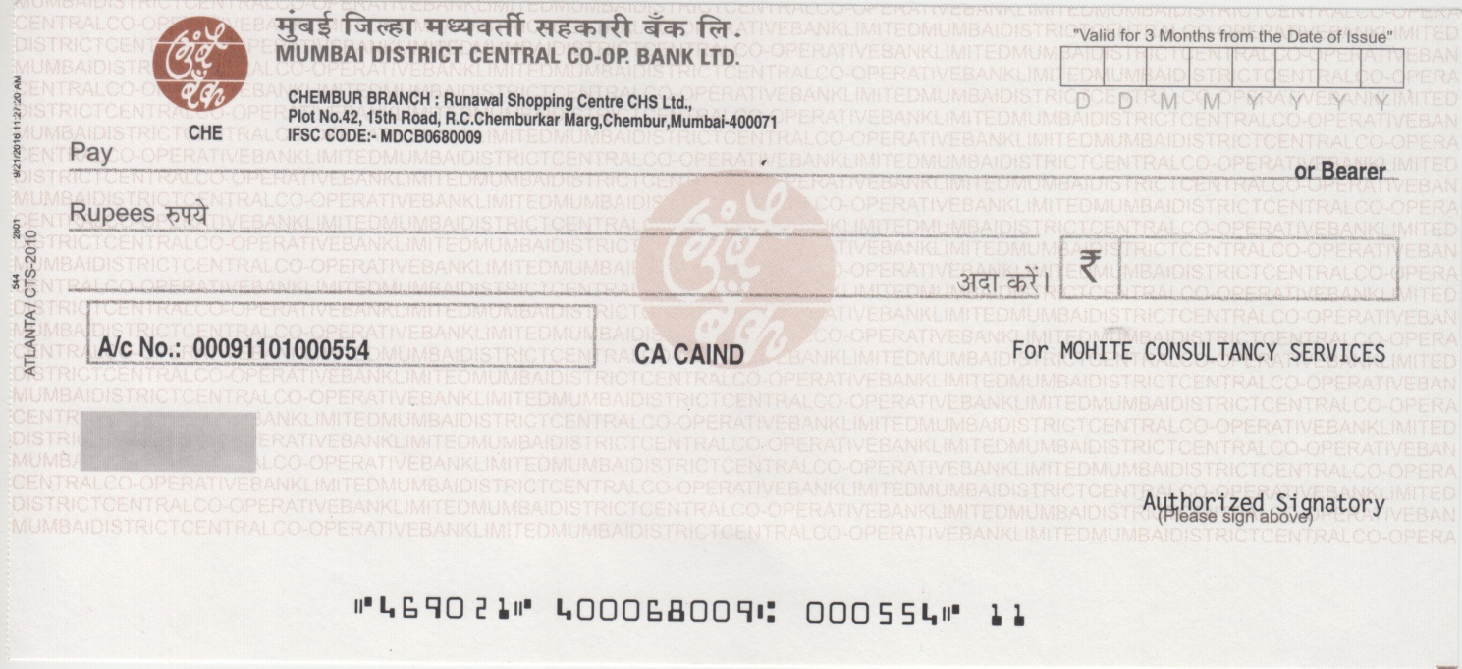

**For M/s Mohite Consultancy Services**

**Partners Partners**